# ARRAY C++

# Practice 01:

# Find second largest or second smallest number

# Sort the array in ascending order (basic logic)

# Sort the array in descending order

# Count how many numbers are greater than the average

# Count how many elements are equal to the index (i.e., num[i] == i)

# Practice 2:

# Find sum of all array elements

# Count even and odd numbers

# Find difference between max and min

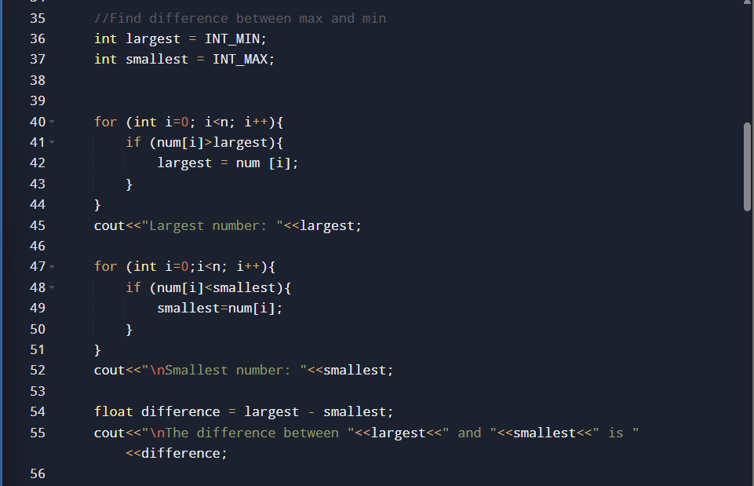

# Calculate average of array elements

# Reverse and print the array

# Print only negative numbers

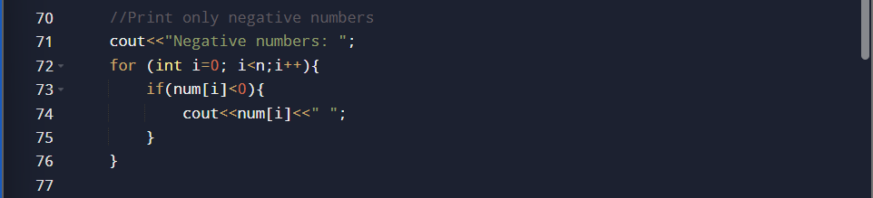

# Count how many numbers > 50

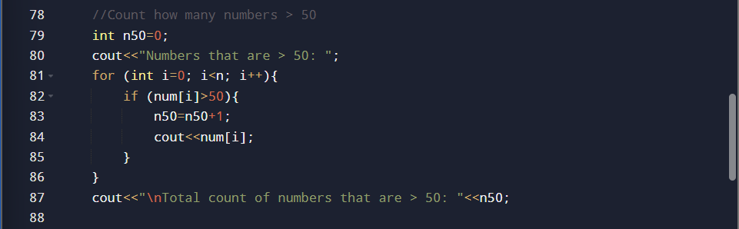

# Find second largest number

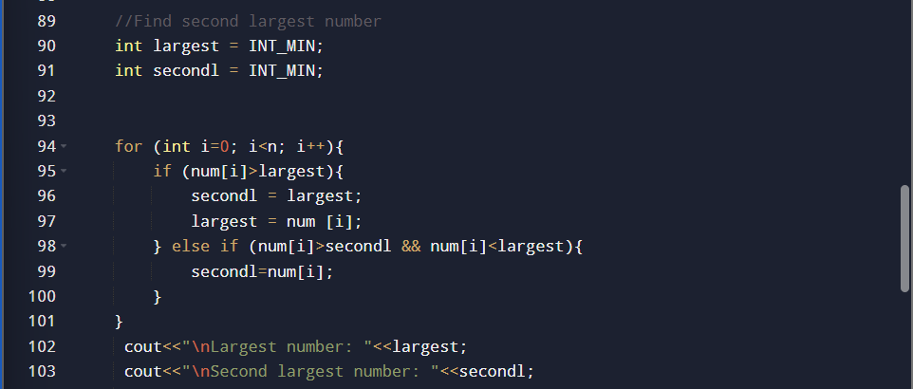

# Find second smallest number

# Count how many times a number appears

# Check if a number exists in array

# Find index of largest number

# Swap first and last element

# Sort array in ascending order (basic bubble sort)

# Sort array in descending order (basic bubble sort)

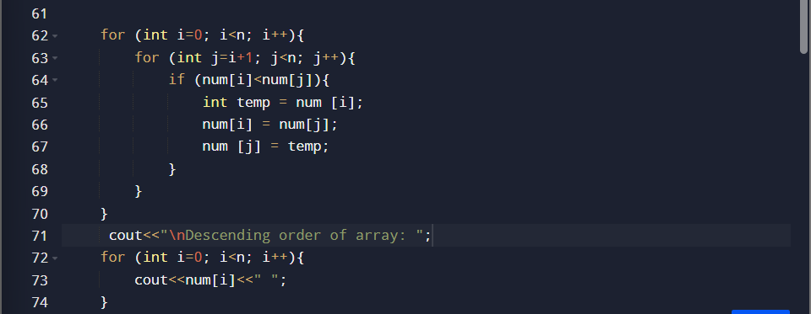

# Print only prime numbers

# Find sum of even-positioned elements

